

**Design Report of an electric-BLDC-powered, propeller driven, radio controlled, heavier-than air aerial vehicle**

*Submitted by*

**Team GlideX**

**NIT Trichy**



Abhiram

Shreepad Narasimhan

Sheel shah

G Sindhuri

Sai Charan Golsu

S R Harshini

# Project Abstract

The following document is a design report that gives enough detail to the necessary rationale behind the decisions taken in relation to design, analysis and fabrication of a micro-class aerial vehicle keeping in mind the constraints imposed by the organizers of the competition. These include constraints on the type of propulsion system, the size constraints on the plane and weight restriction of 800 grams. The challenge thus imposed required the design of a plane capable of executing maneuvers and dropping the given pay load whilst still being stable in flight.

# Design constraints

The rulebook of the competition clearly states the maximum weight of the plane must not exceed 800 grams. The plane must also be able to fit in a box of dimensions 700X700X700mm. The plane should only be powered by a propeller and the use of IC engines were forbidden. Metal propellers are also banned Also, payload release mechanism must be such that its dimensions could handle the payload (a golf ball of diameter 4.3 cm and weight 45 g). A landing gear was also provided as the plane could not be hand thrown and needed to takeoff.

# Weight estimate

Learning from our mistakes from the previous competitions we changed the design algorithm we chose to implement. While previously the velocity of the plane and hence the region of operation of the airfoil was determined first, we chose to attack the problem head-on. WE chose to estimate our weight first and then obtain the necessary Reynold’s number to get the necessary lift. By capping its weight, we could decide on appropriate wing and fuselage designs and could also choose our materials for constructing the plane. The weight of the plane also gave us the required lift that needed to be produced by the wings and the velocity it would need to fly at which would in turn affect our choice of a propulsion system. In order to minimize the weight of the plane, most of our plane was constructed using light materials of low density such as choroplast and depron.

# Fuselage design

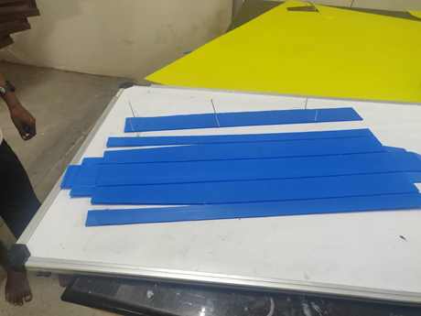Our fuselage was made entirely of choroplast to minimize the weight of the plane. It was supported using choroplast cut-outs whose flutes ran perpendicular to the flutes of the outer choroplast which were reinforced by small carbon fibre rods of 2.5 mm diameter. Cycle spokes were used to prop up the sides of the fuselage such that some rigidity was imparted to the shape of the fuselage. It also had some aero ply support in the bottom to help protect the body form impacts.***(Alongside: Choroplast being used for fuselage construction)*** The front of the fuselage was reinforced to help support the propeller mount which was an aluminium L clamp with holes drilled in. the fuselage of 60 cm long in order for the size constraint to be met while still keeping the fuselage long enough for the tail to be effective. The fuselage was designed to be nose heavy and its centre of mass was located 28 cm from the tip of the fuselage. The fuselage also housed the payload dropping mechanism whose centre of mass was also placed at the exact location such that there would be no change in centre of mass after the payload was dropped. Some pictures of the initial choroplast cut-out, the final fuselage and the cad model are given. 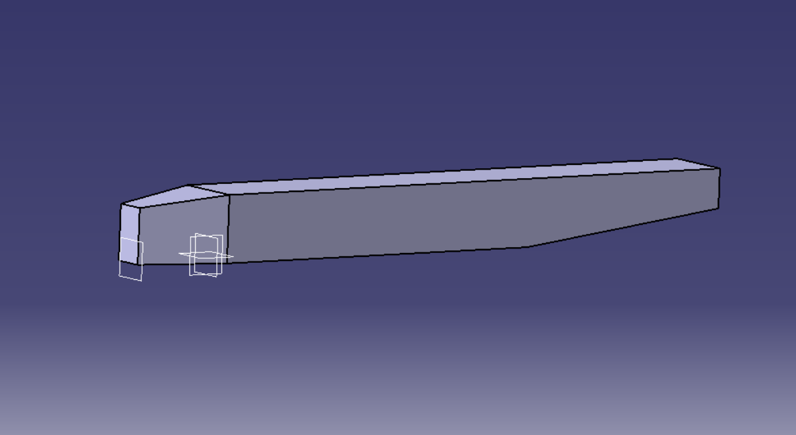

*CATIA model of the fuselage*

# Wing design

We wanted a design of the wing that could help us maximize our payload fraction, maximize lift and minimize drag. The two most important features of the wing are its geometry and the airfoil; the parameters required for unambiguously defining a wing and ensure ease of fabrication. While designing the geometry of the wing we took into account the span, aspect ratio and the planform of the wing.

# *Span:*

Going by the constraints imposed by the organizers, we decided on getting our span right to avoid crossing the rules. We set our span at 90 cm to ensure that we got maximum lift while still being able to fit the plane in the given box. We wanted to maximize the span as the increase in lift provided by a wing with a larger span overshadowed the gain in weight. This allowed us to increase the payload fraction of the aircraft. The large span of the wings also allowed us to reach the required amount of lift at lower velocities and at different angles of attack, hence giving us a reasonable resistance to environmental changes that could cause changes in effective angle of attack or reduce the relative velocity without resulting in a crash. The payload fraction of an aircraft in relation to the span can be obtained by applying the definition of the quantity and simply taking cruise conditions:

$$P.F=η=\frac{\left(\frac{1}{2}ρv^{2}C_{L}-\frac{W_{r}}{s^{2}}AR-φ\right)}{\frac{1}{2}ρv^{2}C_{L}}$$

Where Wr denotes the weight of the plane excluding the wings and φ is the areal density of the wing. The rest of the symbols have their usual meaning. From the above equation we can conclude that payload fraction increases with increasing span and it’s in our favor to maximize the span especially when there is no weight cap to get a better payload fraction.

# *Aspect ratio*

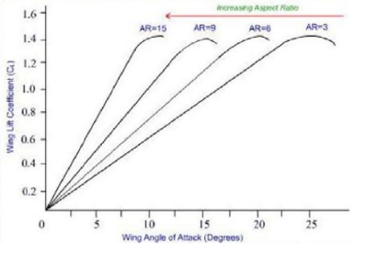Aspect ratio of the wing is defined as the ratio of the square of its span to its area. It determines several properties of a wing such as the 3-D lift coefficient slope of a wing, induced drag and the

*Wing lift vs. Aspect ratio*

glide ratio of the plane. The aspect ratio also affects the lift generated by the wing for a constant span. We know for a given span, lift will increase with decreasing aspect ratio, so a very high aspect ratio would not produce much lift for a given span. Also if the aspect ratio is very high, the resultant chord will be small, which would reduce the Reynolds number of flow over the airfoil, giving us undesirable flow characteristics. On the other hand a very low aspect ratio will produce lift but will also result in high induced drag which will lower the plane’s velocity and will end up decreasing the total lift that the wing generates. Hence an intermediate value of aspect ratio is necessary to ensure adequate lift and ensure proper flow around the airfoil. For our plane we took the aspect ratio at an intermediate value of 4.5 following the graph above.

# *Planform*

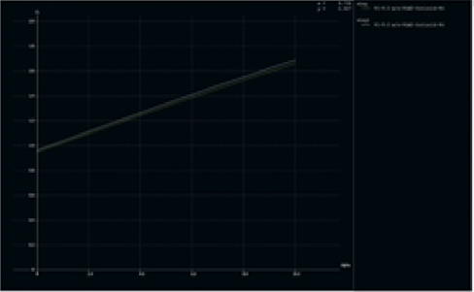Our planform choice was rectangular due to the method of fabrication we used as it did not allow for a taper. We chose our method of fabrication over the gain in lift due to a taper as the method that would allow us to introduce a taper would result in a wing weight of 400 whereas our wing weighed around 270 grams with an almost identical CL which is why we chose the rectangular taper. The introduction of taper barely changes the CL as seen from the graph.

# *Airfoil selection*

Airfoil selection is the most important part of designing a wing. We considered lift characteristics, lift vs drag characteristics, stall characteristics and variation with Reynolds number. In the end we ended up choosing the s1210 airfoil. This is mainly because of the very favourable stall characteristics as it did not stall all the way up to 20 degrees unlike more cambered alternatives like s1223 which stalled at around 8 degrees at lower Reynolds numbers. Another reason we chose s1210 was the lack in variation of cl with Reynolds number which was very useful as that way even without knowing the velocity of flight, we were able to fix the CL of the wing allowing us to calculate the required velocity of flight for our particular wing configuration.

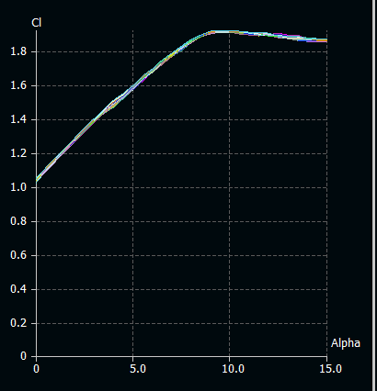 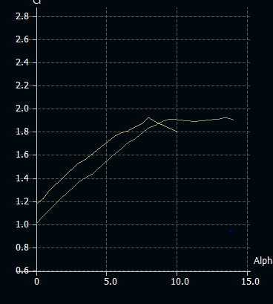

*Virtually no variation of cl with Reynolds number* *Favorable stall characteristics vs. s1223*

# Wing Fabrication

To make our wing, we used depron cut-outs in the shape of the s1210 airfoil which we used as the frame of the wing. This was reinforced using carbon fibre rods. Each depron airfoil had a chord length of 20 cm and was 6 mm thick. This frame was then covered using choroplast. To make the choroplast bendable and flexible, we cut every alternate flute of the chloroplast and made it roll able. We then wrapped our frame and laminated our surface using tape to make the surface smooth. Due to the weakness of the depron airfoils towards the edge, we made the ailerons as big as the span and they were made of cambered depron pieces which allowed for a proper camber for the wing. The following page has the necessary build photos of the wing and its construction.

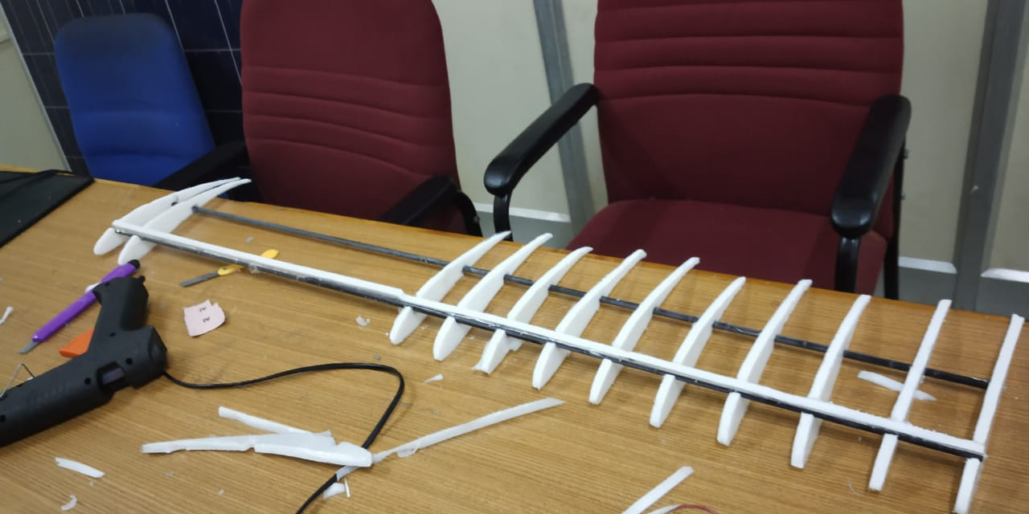 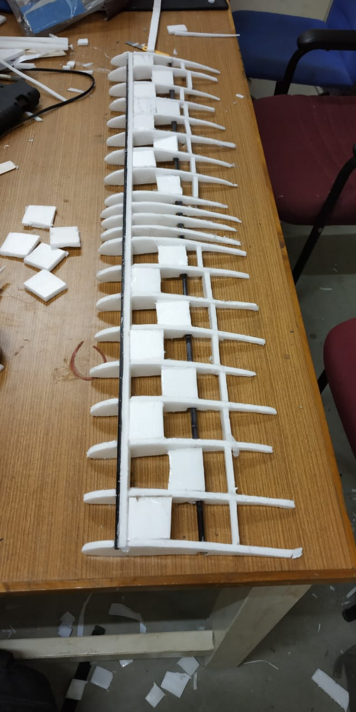

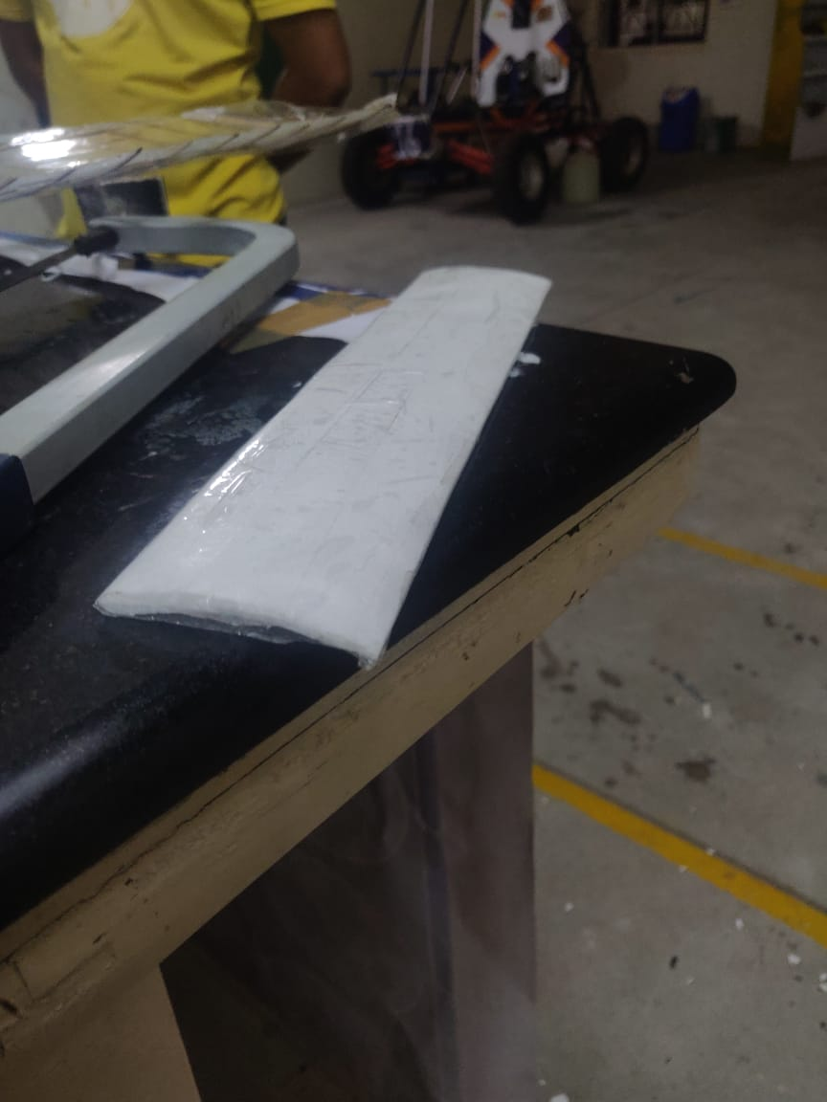 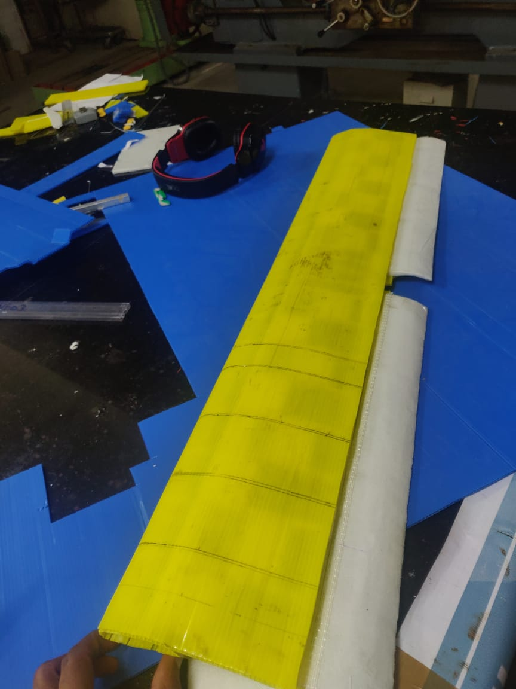

# Velocity estimate of the plane and propulsion requirement

The velocity at which the plane should fly at is obtained by the lift equation:

$$L=\left(\frac{1}{2}ρv^{2}\right)AC_{L}$$

Using lift weight equality in steady flight, we get the required velocity at steady flight as 9 m/s. This is achieved using an appropriate choice of a propulsion system consisting of the motor and the propeller blades. Propeller blades are essentially airfoils stacked adjacent to each other. Hence we approached the problem mathematically by modeling a blade element of the propeller at 70 percent of the radius of each blade as done most often in propeller blade element theories. Consider the **blade element at 70 percent** **of the radius of the propeller blade**. For all RC propellers the angle of attack for a given velocity is ensured constant for all airfoil sections by providing a constant pitch angle. Hence corresponding to a given flow velocity there is a definite angle of attack for all sections. This can be found out by employing simple trigonometry.

The net aerodynamic force this section generates is resolved as the thrust force it provides and the force responsible for creating the counter-torque and deciding the RPM of the motor. The equation for the thrust therefore is calculated by applying the basic airfoil lift equation and resolving forces.

$$T\left(v,ω\right)=\frac{1}{2}ρA(0.7Rω)(\sqrt{{\left(0.7Rω\right)}^{2}+v^{2}})\left(C_{L_{o}}+ C_{L_{α}}\left(θ_{p}-\tan^{-1}\left(\frac{v}{0.7Rω}\right)\right)\right)$$

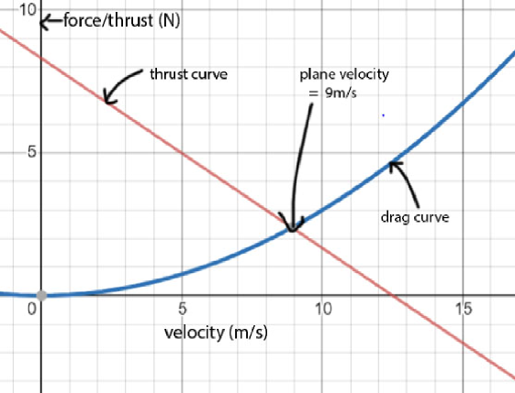In simple terms it is the basic lift equation applied to a propeller blade considering appropriate airflow. Here R is radius of the propeller blade and ω is the RPM of the motor. Plotting the drag curves on the same plot as the thrust-velocity curve using XFLR data while tweaking the RPM of the motor so that we get the desired velocity of 9m/s we decided on a motor prop combination of *(Above: the thrust velocity and drag velocity curves plotted in desmos)* 1200-kV BLDC motor with 10x4.5 in prop. The wing was analyzed in ansys later on for greater precision and accuracy. The pictures of the same are given below.

# 

# *Horizontal stabilizer and elevator sizing*

An aircraft has three axes about which its motion can be analyzed. These are the longitudinal, lateral and directional axes. Two of these namely the horizontal stabilizer and the rudder are responsible for the stability of the plane in the longitudinal and directional axes respectively. Both of these are attached at the empennage for most conventional aircraft. The horizontal tail provides longitudinal stability and controls pitching moment of aircraft. The sensitivity of pitch is determined by horizontal tail volume coefficient given by:

$$V_{H}=\frac{S_{H}l_{H}}{SC}$$

Where, SH=horizontal tail area, LH=horizontal tail moment arm, S=reference area (wing area), c=wing chord (mean aerodynamic chord). A well-behaved aircraft has VH in the range of 0.3 to 0.6, LH at 55% of fuselage length which gives us 33 cm. Taking VH as 0.3 we get area of horizontal stabilizer as 390 cm2. Hence the sum of root and tip chord, Croot+Ctip, is 26. For easy movement of elevator, we take Ctip=7.5 and hence Croot=18.5. As per a document put up by IIT Madras as a part of an NPTEL course, the aspect ratio of horizontal tail should be in range of 2 to 5 and taper ratio should be 0.3 to 0.6. Therefore, taking aspect ratio=2.3 we get span of horizontal stabilizer to be 30 cm.

# Rudder sizing

The aircraft rudder was designed by examining its influence on the degree of aileron responsiveness and effectiveness as some hiccups were encountered during test-flight. We observed the aileron and the rudder counter themselves in trying to roll the plane in specified direction. Hence the moment of rolling due to the rudder and the aileron must bear a specific relation to ensure proper responsiveness either of the control surfaces. To investigate this we chose to approach the problem analytically. Aircraft roll due to aileron actuation happens due to the change in lift caused due to the alteration in the camber of the airfoil. This was integrated over the strip of the wing that had the aileron and the rolling moment due to the aileron actuation for 20 degrees was calculated. What opposes this moment is the rolling moment of the rudder caused due to crosswind, a factor that stood out quite starkly during all our test flights. The moment due to the rudder was also calculated by assuming crosswinds of 4m/s. As a result, we coined a roll-responsiveness parameter φ that is the ratio of the rolling moment caused due to the rudder to the rolling moment of the ailerons. Greater this value smaller the responsiveness and vice-versa.

$$φ= \frac{S_{v}\left[1+{\left(\frac{v_{cross}}{v_{plane}}\right)}^{2}\right]\left(\frac{2πAR}{2+\sqrt{4+{AR}^{2}}}\right)\tan^{-1}\left(\frac{v_{cross}}{v_{plane}}\right)\overline{y_{v}}}{δ_{A}C_{L_{α_{wing}}}\left[C_{root}\left(bl-{\frac{l}{2}}^{2}\right)+\frac{2}{3}\left(\frac{λ-1}{b}\right)(l^{3}+3bl\left(b-l\right)) \right]}$$

Here vcross, vplane denote the cross-wind velocity and the plane velocity, b is the span, l is the aileron length, AR denotes the aspect ratio of the rudder, yv the centroid position vertically from the fuselage of the rudder, δA the deflection of the aileron in degrees and CLwing the slope of the lift coeff. Vs alpha graph and Croot the length of the root chord. An appropriate value of the parameter φ can be used to calculate the size of the aileron. This factor was set to 1/3 to get the appropriate size of the rudder for a given outboard wing-size aileron. Assuming an aspect ratio of 1.5 we get the size of the rudder as follows: root chord: 14.5cm , tip chord: 7.5cm, height: 16cm.

# Longitudinal stability

Albeit we require a maneuverable plane, the stability of the plane can be altered to various degrees by positioning the COG and neutral point of the plane accordingly. To provide an analytical basis to the stability of the plane and look at the effects of various parameters that influence the plane stability along the longitudinal axis, a generalized moment equation about the COG of the plane was used. A trim of 5 degrees was used for the wing to get the desired lift for the aircraft to balance its weight. This was then altered by converting all terms of the equation into coefficients instead of forces. Required data was plugged in from XFLR 5 analysis of the wing. The simplified equation reads:

$$C_{m}= C_{mac}+(C_{L})\frac{l_{cg}}{c}-V_{H}\left(C_{L_{E}}\right)$$

Expanding the terms within the stall region:

$$C_{m}= C_{mac}+\left(C_{L_{o_{p}}}+s_{p}\left(α+5\right)+\frac{A_{t}}{A_{w}}\left(C_{L_{o_{e}}}+s_{e}\left(α+t+ε_{0}cosβ\right)\right)\right)\frac{l_{cg}}{c}-V_{H}\left(C_{L_{o_{e}}}+s_{e}\left(α+t+ε_{0}cosβ\right)\right)$$

The various symbols mean the following:

*Cm* : The moment coefficient of the plane.

*Cmac*: The moment of the wing of the plane about the mean aerodynamic chord

*CLo­p*: The lift coefficient of the plane at zero angle of attack

*Sp*: The slope of the lift coefficient-alpha curve for the plane

*α*: Angle of attack without trim

*5*: trim setting for the wing

*At*: Area of the elevator

*Aw*: Area of the wing

*CLo­e*: Lift coefficient of the elevator at zero angle of attack

*Se*: slope of the elevator lift coefficient-angle of attack graph

*t*: Trim setting of the elevator

*ε0*: downwash angle for the elevator placed in line with the wing

*β:* Elevation angle of the elevator from the MAC of the wing for a T-tail

*lcg*: Distance of the COG of the plane from the MAC

*VH*: Volume coefficient of the horizontal stabilizer = SHlH/SC; with lH and SH denoting the distance of the horizontal stabilizer from the MAC of the wing and the total area of the elevator respectively.

Differentiating the simplified equation above and setting it less than zero for longitudinal stability, we arrive at:

$$l_{cg}≤c\frac{s_{t}}{s_{w}}\left(1-\frac{∂ε}{∂α}\right)V_{H}$$

At neutral point:

$$l_{np}= c\frac{s_{t}}{s_{w}}\left(1-\frac{∂ε}{∂α}\right)V_{H}$$

According to an NPTEL Document on empennage sizing VH is fixed at 0.3 for stabile planes. The slopes can be gotten readily from the graphs of XFLR5. The chord is fixed at 19.16 (Mean Aerodynamic Chord). To evaluate the downwash effects, consider the following equation:

$$C_{L_{plane}}= C_{L_{wing }}+ C_{L_{elevator}}.\frac{A_{w}}{A_{E}}$$

Differentiating:

$$\left(1-\frac{∂ε}{∂α}\right)= \left[\frac{C_{L_{α_{p}}}-C_{L_{α_{w}}}}{C_{L_{α_{E}}}}\right]\frac{A_{w}}{A_{E}}$$

$C_{L_{α_{p}}}$ denotes the derivative of the lift coefficient for the plane and the same for the other notation used in the above equation. Thus, plugging in data into this from XFLR5 and using the result in the equation for neutral point, we get theoretically the value of the neutral point as measured from the leading edge of the wing (as taken from the MAC) as **8.5 unit**s

This now allows examining the degree of stability of the plane. Using the reference of a document by IIT Madras, the degree of stability depends on the magnitude of a parameter ‘SM’ (Short for Static Margin) defined as:

$$SM=\frac{h}{c}=\frac{x_{np}-x_{cg}}{c}$$

For stable planes the value of SM should be between 0.05 and 0.25, with the stability getting smaller with smaller values of the static margin. For this competition that requires the plane to execute limbos, a weakly stable plane with quick response to the elevator flap is preferred. For the plane with neutral point at 8.54 units from we have a SM of 0.17. This is quite reasonable as it falls on the mid-range side of the prescribed values-neither too stable to resist pitching when elevators are pulled-up or down by servos or too unstable to get into haphazard phugoids.

The longitudinal stability analysis was performed directly using XFLR5 and the results obtained showed the neutral point location at **8.87 units.** The closeness of these values indicated the accuracy of the theoretical model used for the longitudinal stability of the aircraft.

To get the plane balance at zero-degree longitudinal pitch attitude, we imposed a condition on the pitching moment. If we somehow ensure it crosses the origin at zero angle of attack, we know our plane is stable at zero pitch-up under steady flight. Therefore consider an initial elevator (flap) trim of δE. From the original equation that governs the stability we get the desired condition as:

$$C_{m_{o}}= V_{H}\left(C_{L_{α_{E}}}ε+C_{L_{α_{E}}}τ_{E}δ_{E}\right)$$

From this we get a value of δE as -15 degrees.